
Symbiosis Institute of Technology, Pune
Faculty of Engineering
CSE- Academic Year 2026-27
Java Programming – Lab Batch 2024-28
Lab Assignment No: - 29
Name of Student: Sanika Botre
PRN No.: 25070122063
Batch: 2025-29
Class: CSE A-2
Academic Year & Semester: 2026 & 3rd Semester
Date of Submission
Title of Assignment: Write a JSP application to demonstrate the basic concepts of Java Server Pages.
Learning Objectives: To develop dynamic web pages using Java Server Pages.
Theory:
Java Server Pages (JSP) is a server-side technology used for developing dynamic web applications. JSP allows Java code to be embedded within HTML pages using special JSP tags. When a JSP page is requested, the web server automatically translates it into a servlet, compiles it, and executes it to generate dynamic web content. JSP supports implicit objects, directives, scripting elements, expression language, and standard tag libraries. It simplifies web development by separating presentation from business logic. JSP is commonly used with Servlets and JDBC for building database-driven web applications.
Practice questions
1. Create a JSP page to display student information entered by the user
Code:
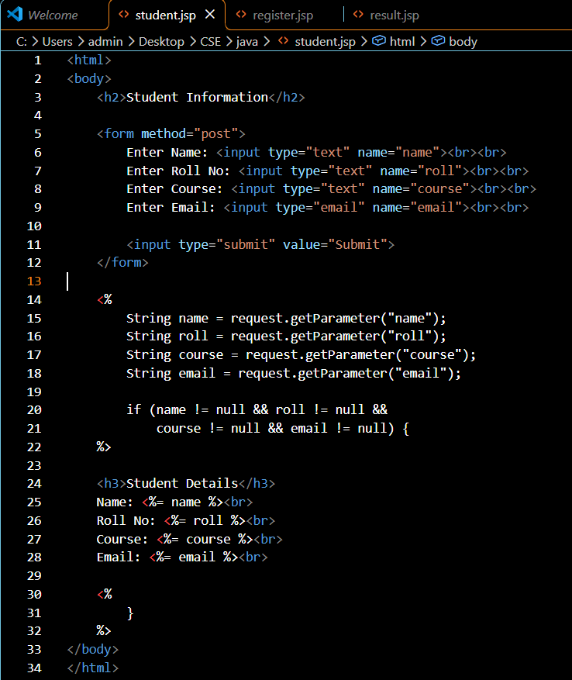

Output:

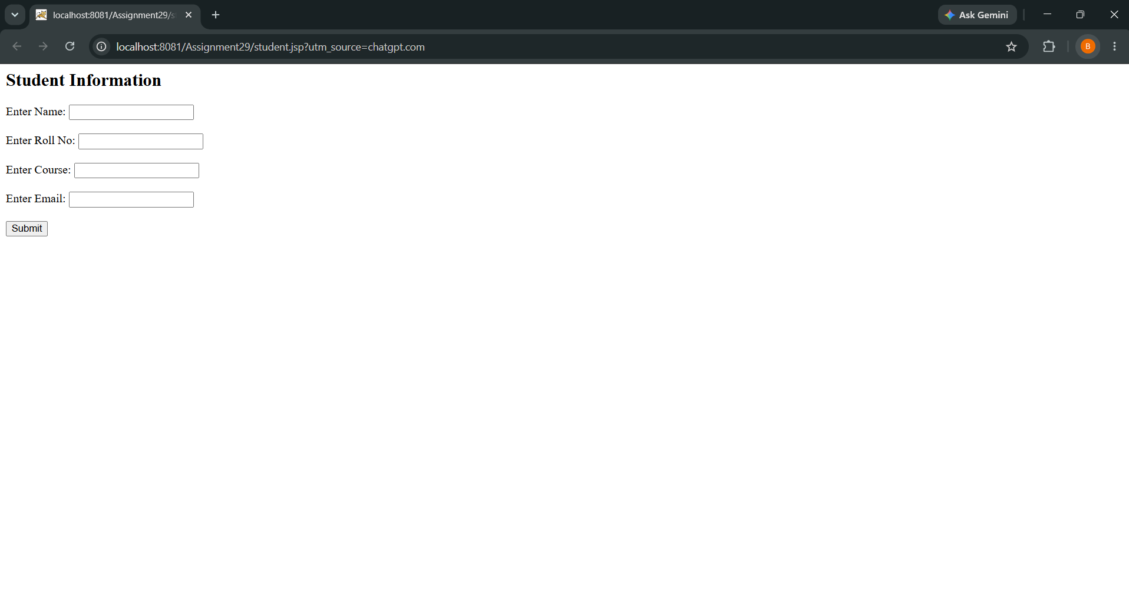

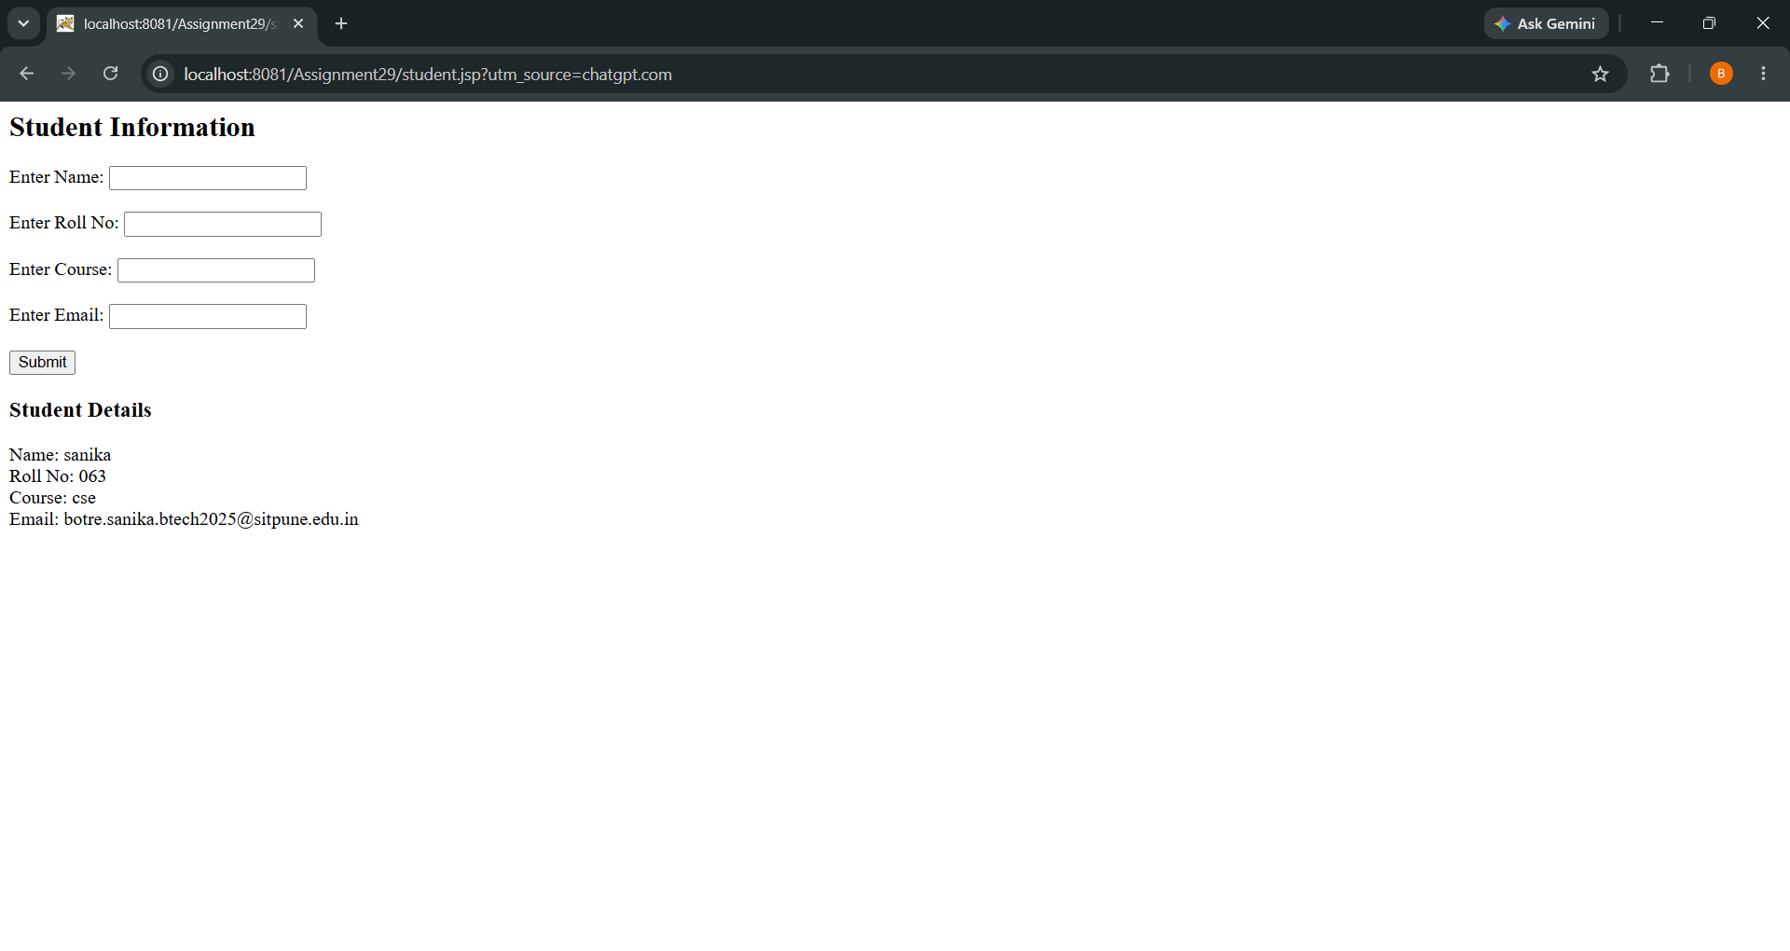

2. Create a JSP application that takes user registration details such as Name, Email, Phone Number, and Password, and displays the submitted information on a result JSP page.
Code
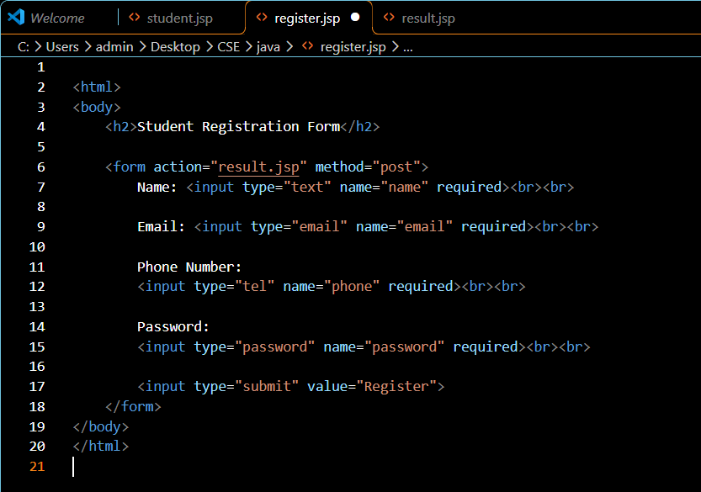
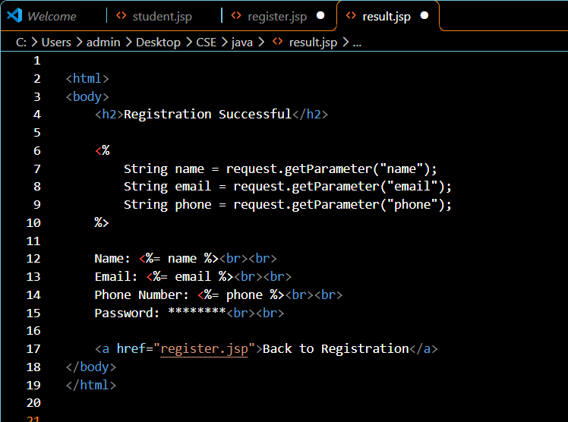
Output:

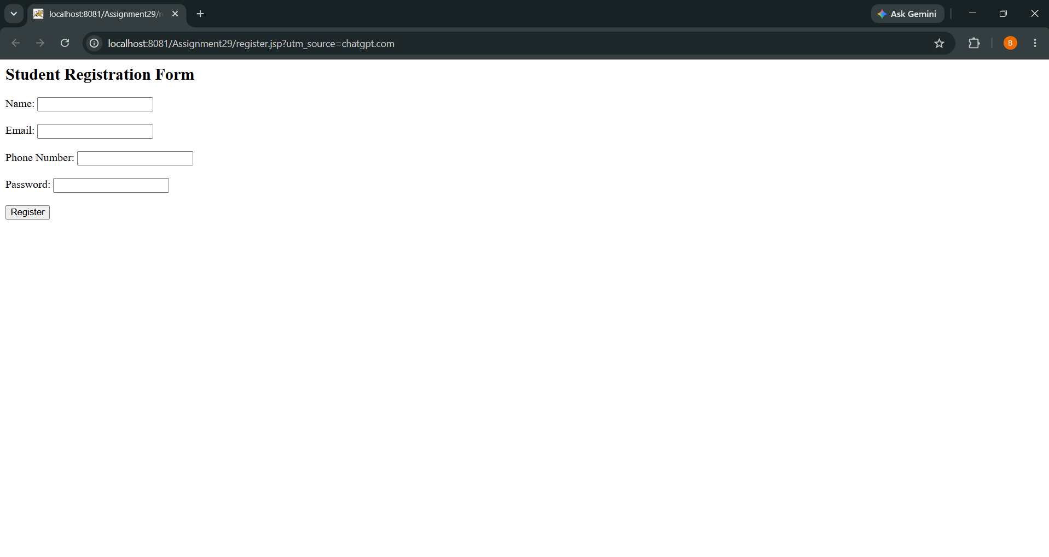

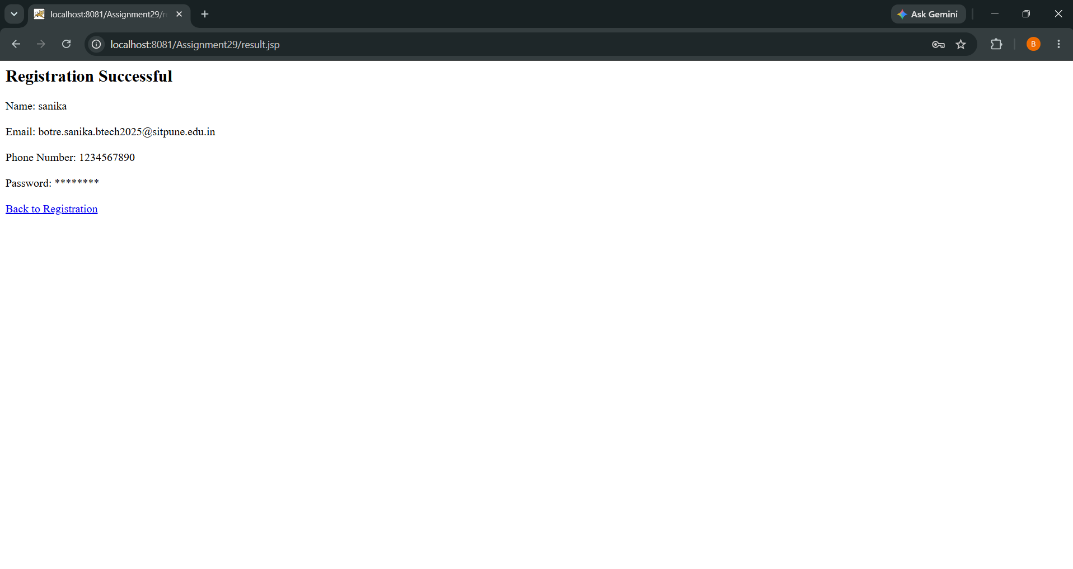

Conclusion
Thus, both JSP applications were successfully created and executed using Apache Tomcat. The first application displays student information entered by the user, while the second application accepts registration details and displays the submitted information on the result JSP page.

